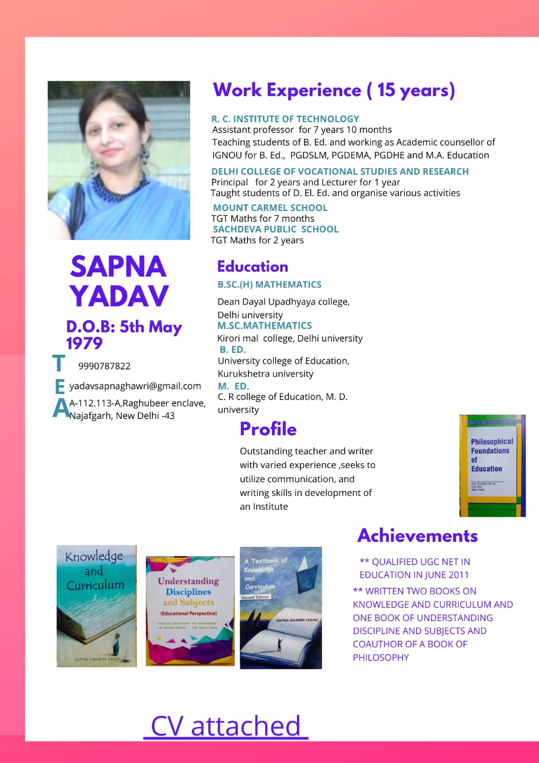

**CURICULUM VITAE**

SAPNA YADAV Contact no. 9990787822,

A-112,113 Raghubir Enclave,

Najafgarh, New Delhi.

Email – yadavsapnaghawri@gmail.com

**Objective**

To obtain a challenging job & responsibility where I can put my knowledge & skills in making important contribution to the growth of an Institute & be always on a learning curve.

**Personal Skills**

I am an enthusiastic person, capable of solving comprehensive problems and having good communication skills.

**Personal Details**

☺ Name - Sapna

☺ Husband’s Name - Ashish Yadav

☺ Father’s Name - Surjeet Singh Ghawri

☺ Date of Birth - 05-05-1979

☺ Nationality - Indian

☺ Languages Known - English, Hindi

☺ Marital Status - Married

**Achievements**

* University Merit Position (10th) in B.Ed.
* Attended 15 days Training course on ‘Research Methods in Social Sciences’ organized by ICSSR, Chandigarh
* Published two books of ‘ Knowledge and Curriculum’ and co-author of one book of ‘Understanding Disciplines and Subjects’ and one book of ‘Philosophy’
* Resource person for FDP’s
* Editor of College Magazine

**ACADEMIC CHRONICLE**

* **UGC NET (EDUCATION) June 2011 QUALIFIED.**

|  |  |  |  |  |  |
| --- | --- | --- | --- | --- | --- |
| Sr.  No. | Examination  Passed | Board/University | Institute | Marks  Obtained | Percentage |
| 1 | M.Ed. | Maharishi  Dayanand  University | C.R College  of Education | 500/800 | 62.5 % |
| 2 | M.Sc.(Maths) | Delhi Univ. | Kirori Mal  College | 1114/1600 | 69.6 % |
| 3 | B.Ed. | Kurukshetra  Univ. | University  College of  Education | 600/900 | 66.6 % |
| 4 | B.Sc.(Hons)  (Maths) | Delhi Univ. | Dean Dayal  Upadhyaya  College | 496/900 | 55 % |
| 5 | Senior  Secondary  Examination | C.B.S.E. | Bal Bharti  Public School | 347/500 | 69.4 % |
| 6 | Secondary  Examination | C.B.S.E | D.A.V.  Centenary  Public School | 405/500 | 81 % |

**Experience (15 Years)**

|  |  |  |  |  |
| --- | --- | --- | --- | --- |
| Sr.  No. | Name of Institute | Post  held | Duration | Experience |
|  | Kalka Institute for Research and Advanced Studies | Asstt. Professor(B.Ed.) | 14th Nov.2022  to till date |  |
|  | R.C.I.T | Asstt.  Professor (B.Ed.) | 1st August 2014 to  30th June 2022 | 7 years 11  months |
|  | M.D. College of Education | Asstt. Professor | 25 November 2013 to  27th March 2014 | 4 months |
|  | Haryana Shakti College of of Education, Kanjhawala,  New Delhi | Asstt. Professor(B.Ed.) | 1st Aug.2012 to  30th September 2013 | 1 yr.and  2 months |
|  | Delhi College of Vocational  Studies &Research ,  Baprola, Jai Vihar, New Delhi. | Lecturer  (DIET) | 1st  July 2009 to  30th June 2010 | 3 yrs & 1  month |
| Principal | 1st July 2010 to  31st July,2012 |
|  | Mount Carmel School,  Anand Niketan, New Delhi. | TGT  (MATHS) | 1st Apr. 2008 to  10th Nov.2008 | 7 months |
|  | Sachdeva Public School,  Pitampura, New Delhi. | TGT  (MATHS) | 24th June 2004  to 26th June 2006 | 2 yrs. |

**Book Published**

|  |  |  |  |
| --- | --- | --- | --- |
| **Sr. No.** | **Title** | **Publisher, Year** | **ISBN No.** |
| 1 | Knowledge and Curriculum | Paragon Publications, 2016 | 978-93-83154-39-5 |
| 2 | A Textbook of Knowledge and Curriculum | Paragon Publications, 2018 | 978-93-83154-61-6 |
| 3 | Understanding Discipline and Subjects | Bookman, 2018 | 978-93-86713-79-7 |
| 4 | Philosophical Foundations of Education | Twenty first century Publications ,2019 | 978-81-934250-4-6 |

**Chapters in Edited Books**

|  |  |  |  |  |
| --- | --- | --- | --- | --- |
| Sr. No. | Name of Book | Publication | Name of Chapter | ISBN No. |
| 1 | ICT Practices in Teaching Learning | Writers Choice Publications Pvt. Ltd | Social Networking sites: A platform for Interactive learning | 978-93-90965-12-0 |
| 2 | Systematic concerns of Teacher Education in 21stcantury | Bansal Publishers | Preparing teachers for Inclusive Education | 978-93-86490-15-5 |
| 3 | Psychology Curriculum, BOSSE  (Sr. Secondary) | BOSSE, SIKKIM | Knowledge And Wisdom in Psychology | Study Material |
| 4 | Psychology Curriculum, BOSSE  (Sr. Secondary) | BOSSE, SIKKIM | Attitudes | Study Material |

**Research Papers/Articles published in Journals and Conferences**

|  |  |  |  |
| --- | --- | --- | --- |
| **Sr. No.** | **Title** | **Journal, Volume, Year, Page Numbers** | **ISSN / ISBN No., if any** |
|  | Role of Technology in Facilitating Teacher Education | Aaroha Journal of Education & Management, Volume-5, Issue-I, Dec,2016-Dec,2017 | ISSN: 2320-1266 |
|  | Two year B.Ed. Prgramme:A Step towards Quality Education | National Conference on Relevance of Two years B.Ed and M.Ed. Programmes Challenges and Ground Realities :An Empirical Analysis. April 2017 | ISBN 978-81-924703-7-5 |
|  | Digitalization of Education : A Step towards Developed India | National Conference on Paradigm Shift from Developing to developed India through Digitalisation,2017 | ISBN 978-93-86238-24-5 |
|  | Role of ICT in Learning and Teaching Effectiveness | National Conference on Innovations in IT , Management and Education, 21st March 2015 | ISBN:978-16-31024-51-1 |
|  | Building Positive Teacher-Student Relationship in today’s classroom. | International Multidisciplinary e-journal,  Vol-V, Issue-I0, 2016 | ISSN : 2277-  4262 |
|  | Role of ICT in Teaching Learning Effectiveness | Aroha Journal of Education and Management(2016) | ISSN:2320-1266 |
|  | Scope of Massive Open Online Courses for Professional Teacher Development | International Education Conference2015, Learning Technologies in Education | ISBN:978-93-84869-29-8 |
|  | Teaching as a Career preference of secondary school students in relation to some demographic variables | Awadh International Journal of Informational Technology and Education (AIJITE), Volume3, September, 2014 | ISSN :  2277-8985 |
|  | Role commitment of secondary school teachers in relation to some demographic variables | Journal of Educational and Psychological Research, Volume 4 ,Jan 2014 | ISSN:2230-9586 |
|  | The Right to Education : Reality or a distant dream | ShikshanAnveshika,,Vol III,No.2, July 2013 | ISSN:2231-1386 |
|  | Impact of Emotional Intelligence on Teaching Competence of Student teachers | MERI Journal of Education ,Vol7,No.2, Oct 2012 | ISSN: 0974-2085 |

***WEBINARS ORANISED***

|  |  |  |  |  |
| --- | --- | --- | --- | --- |
| Sr. No | ***Date*** | ***Theme*** | ***Resource Person*** |  |
| 1 | 5th June 2021 | Mental Health concerns during Covid-19 pandemic | Ms Sandhya Gulia |  |
| 2 | 26th June 2021 | NEP 2020- Future Roadmap of India | Dr.Anjali |  |

**Paper Presentations in Seminars/ Conferences**

|  |  |  |  |  |  |
| --- | --- | --- | --- | --- | --- |
| **S.NO.** | **Organization/ Association** | **Event** | **Year** | **Theme** | **Title of Paper** |
|  | USE, GGSIPU | National Conference | 29th -30th Jan 2018 | Innovative Pedagogies for Creation of Enriched Teaching Learning Environment in Higher Education | Project Based Learning: A Dynamic of knowing and Doing |
|  | Pradeep Memorial Comprehensive College of Education | National Seminar | 29th May 2018 | Education for Diversity and Social Justice | Recommendations of NCF 2005 on Diversity and Social Justice |
|  | Maharaja Surajmal Institute | National Conference | 28th -29th July 2017 | Paradigm Shift from developing to Developed India through Digitalization | Digitalization of Education – A Step Towards Developed India |
|  | NIOS | National Seminar | 23rd -24th March 2017 | Sa Vidya Ya Vimuktya | Practical Knowledge supports better Acquisition of Theoretical Knowledge |
|  | Ganga Institute of Education(ICSSR Sponsered) | National Seminar | 29 -30th March 2016 | Reforms in Teacher Education | Role of ICT in enhancing the teaching competency of Teachers |
|  | Maharaja Surajmal Institute | National Conference | 21st March 2015 | Innovations in IT , Management and Education | Role of ICT in Learning and Teaching Effectiveness |
|  | Jamia Millia Islamia | International Conference | 24 – 25th Feb. 2015 | Learning Technologies in Education | Scope of MOOC for Professional Teacher Development |
|  | Institute of Vocational studies | National Seminar | 28-29th Nov 2014 | Developing Technologically Competent Teachers | ICT a boon in Teacher development |
|  | Fairfield Institute of Management &Technology | National Seminar | 21-22nd Feb 2013 | The Right of Children to free and Compulsory education | Right to education :Reality or a Distant Dream |
|  | BLS | National Seminar | 29th March 2011 | Woman Empowerment | Challenges in Woman Education |

**Participation in Seminars/ Conferences/ Workshops**

|  |  |  |  |  |
| --- | --- | --- | --- | --- |
| **S.NO.** | **Organization/ Association** | **Event** | **Year** | **Theme** |
|  | BPS Institute of Teacher Training and Research | International Conference | 28th -29th March 2022 | Idea- Bankruptcy of Educationists and Thinkers |
|  | MGNCRE | Workshop | 29th September 2020 | VENTEL action Plan |
|  | PMC College of Education | Seminar | 6th march 2019 | Preparedness of school for inclusion and classroom practices for inclusive setting |
|  | Vaish Arya Shikshan Mahila Mahavidyalaya | Workshop/ FDP | 27th -31st May 2018 | Information Technology along with Innovative Teaching Practices |
|  | PMC College of Education | Seminar | 29th May 2018 | Racial, Ethnic and Cultural Diversity |
|  | IGNOU | Orientation Programme | 1st -2nd September2016 | Orientation Programme for Academic Counellors |
|  | AIIMS | Awareness Programme | 10th March 2016 | Keeping Kidneys Healthy –Do’s and Don’ts |
|  | Amity Institute of Education | National Conference | 12th -13th November 2014 | Corporate Governance and its Role in Minimizing the Isolation of Teacher Education |
|  | SRITE | National Seminar | 23rd -24th January 2013 | Faculty Enrichment in Societal Development |
|  | Institute of Vocational Studies | Workshop | 9th -10th Feb. 2012 | How to conduct Research |

**Professional Training Programme**

|  |  |  |  |  |  |
| --- | --- | --- | --- | --- | --- |
| **S.NO.** | **Organization/ Association** | **Event** | **Year** | **No. of Days** | **Theme** |
|  | **USE,Education, GGSIPU** | **FDP** | **25th -31st October 2021** | **7 Days** | **NEP 2020 : A Roadmap for Future India** |
|  | Sant Hari Dass College of Higher Education | FDP | 26th May-30th May 2020 | 5 Days | Sustainable Education while combating Pandemics |
|  | **USE,Education, GGSIPU** | **FDP** | **10th May-16th May 2020** | **7 Days** | **Design and Development of MOOCs and E-learning Technologies** |
|  | **PMC College of Education** | **FDP** | **7th -13th May 2018** | **7 Days** | **Research Skills Development** |
|  | Gitarattan Institute of Advanced Studies | FDP | 18-22th December 2017 | 5 Days | Educational Development |
|  | SantHariDass  College of Higher Education | FDP | 20th – 25th Feb.2017 | 6 Days | Changing Paradigm in Education in Digital Age |
|  | SantHariDass  College of Higher Education | FDP | 15-20th Jan 2015 | 6 Days | Life Long Learning in 21th century: Need &Essentials |
|  | Kamal Institute of Higher Education&Advance Technology | FDP | 8-12th Dec. 2014 | 5 Days | In Corpora ting Global Perspective into Administration, Teachers |
|  | RCIT | FDP | 2-9th June 2014 | 8 Days | Matlab |
|  | Kamal Institute of Higher Education&Advance Technology | FDP | 20th April 2013 | 1 Day | Research in improving classroom practices |
|  | **ICSSR** | **Training Programme** | **11-25th March 2013** | **15 Days** | **Research Methods in Social Science** |
|  | Guru Ramdass college of Education | FDP | 26th Feb 2013 | 1 Day | Educational Evaluation in school Environment |